SJRC S70W GPS Quadcopter Can’t Connect to Android Phone Via WiFi - Problem

I had difficulty connecting to my SJRC S70W Quadcopter to my Moto E4 Android Phone (Republic Provider).

.

1. Power up Quadcopter
2. Toggle left control “Up” then “Down”.

***\*\*\*\*\*\*\*\* CAUTION - THE COPER CAN FLY AT THIS POINT \*\*\*\*\*\*\****

***MAKE SURE YOUR CONTROLLER CANNOT BE ACCESSED***

1. You should be able to “see” the SJ-XXXXXX offering on your WiFi enabled Cell Phone.
2. Select “SJ-XXXXXX”

It will connect and report “Connected, no Internet”

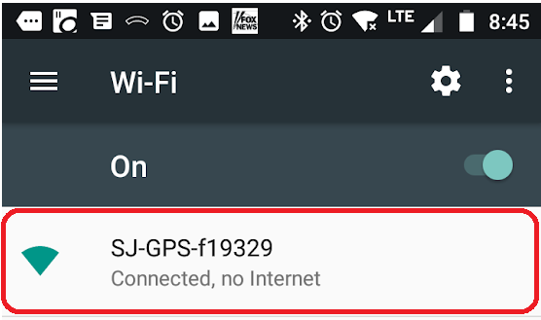

5. Another “pop up” should appear after 5-10 seconds reporting

“Wi-Fi has no Internet access”

“ Tap for options’”

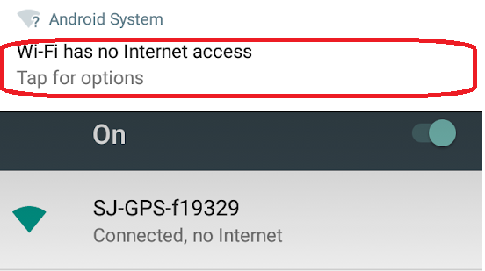

IF THIS POP UP DOES NOT APPEAR WITHING 5 SECONDS SELECT ANOTHER SERVICE AND CONNECT TO IT. AFTER YOU ARE FULLY CONNECTED TO THIS OTHER SERVICE, RETURN TO STEP 4.

6. “Tap” this “pop up”.

7. The “pop up” says:

This network has no internet access.

Stay connected?

8. Select “Yes”

6. Start your SJRC app and select the correct model copter model (slide pictures left/right) and the select control. The screen picture should appear within 5 seconds. **(Stop/Restart SJRC app if it was alreading running).**

IF ALL THIS FAILS, TRY “FORGETTING” THE SJ-XXXXXX service and trying it again.